FINDINGS FOR KOBO

ATTEMPTING TO HAVE ADMIN PRIVLAGES USING USERS:
4, 6, 7, 8, 9, 10, 11, 13, 14, 15, 16, 17, 19, 1, 21

TEST CASE 1: USER 4
Role: Merchant
Email: merchant4@kobo.co.za
LOGIN AS MERCHANT:
Method: POST
Endpoint: /api/v1/auth/login
JSON REQ Body:
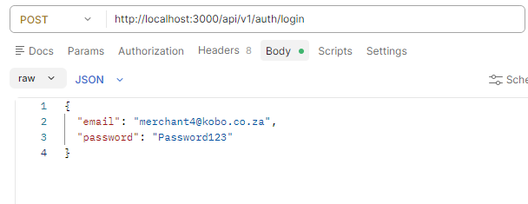
EXPECTED RESULTS:
- Login successful (Status code 200)
- JWT token returned

ACTUAL RESULT: Token recieved

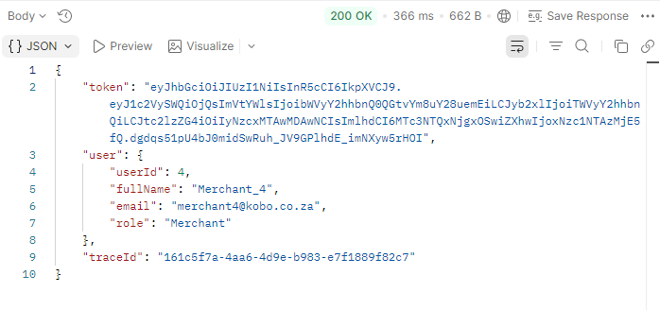
ATTEMPT TO ACTIVATE USER 5 USING USER LOGIN TOKEN:
Endpoint URL:
Expected result:
- Access is forbidden (Error 403 showed)
- The user is denied due to lack of permissions

Actual result: User is denied access
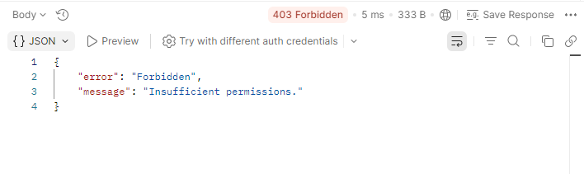

TEST CASE 2: USER 6
Role: Merchant
Email: merchant6@kobo.co.za
LOGIN AS MERCHANT:
Method: POST
Endpoint: /api/v1/auth/login
JSON REQ Body:
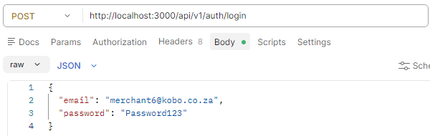

EXPECTED RESULTS:
- Login successful (Status code 200)
- JWT token returned

ACTUAL RESULT: Token received
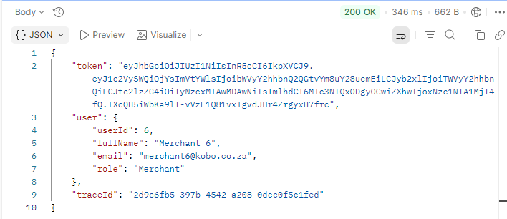

ATTEMPT TO SUSPEND USER 9 USING USER LOGIN TOKEN:
Endpoint URL:
EXPECTED RESULTS:
- Access is forbidden (Error 403 showed)
- The user is denied due to lack of permissions

ACTUAL RESULT: User is denied access
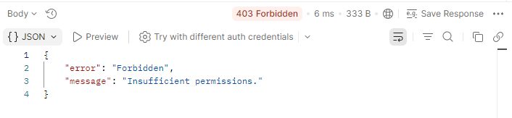

TEST CASE 3: USER 7
Role: Merchant
Email: merchant7@kobo.co.za
LOGIN AS MERCHANT:
Method: POST
Endpoint: /api/v1/auth/login
JSON REQ Body:
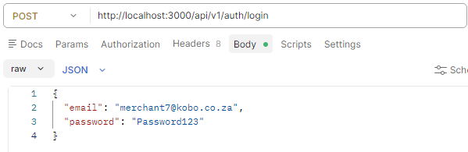

EXPECTED RESULTS:
- Login successful (Status code 200)
- JWT token returned

ACTUAL RESULT: Token received
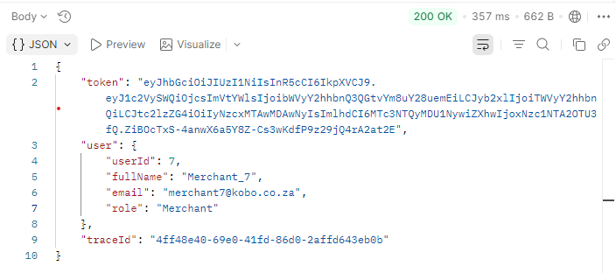

ATTEMPT TO DEACVTIVATE USER 11 USING USER LOGIN TOKEN:
Endpoint URL:
EXPECTED RESULTS:
- Access is forbidden (Error 403 showed)
- The user is denied due to lack of permissions

ACTUAL RESULT: User is denied access
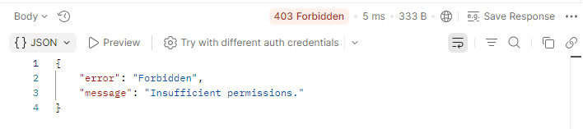

TEST CASE 4: USER 8
Role: Merchant
Email: merchant8@kobo.co.za
LOGIN AS MERCHANT:
Method: POST
Endpoint: /api/v1/auth/login
JSON REQ Body:
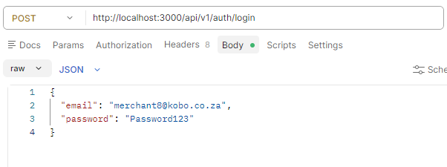
EXPECTED RESULTS:
- Login successful (Status code 200)
- JWT token returned

ACTUAL RESULT: Token received
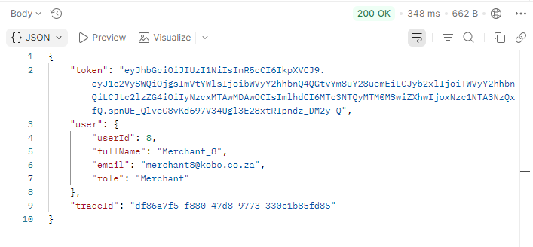
ATTEMPT TO CREATE A PRODUCT USING USER TOKEN:

JSON Request body:
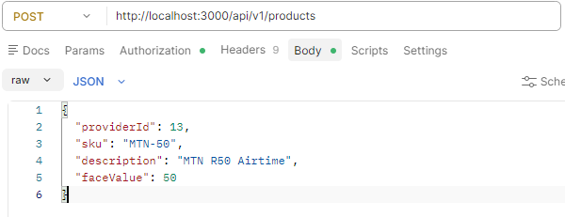

EXPECTED RESULTS:
- Access is forbidden (Error 403 showed)
- The user is denied due to lack of permissions

ACTUAL RESULT: User is denied access
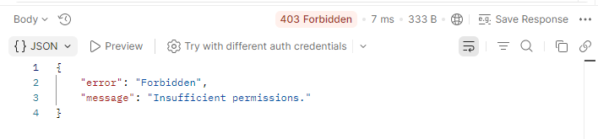

TEST CASE 5: USER 9
Role: Merchant
Email: merchant9@kobo.co.za
LOGIN AS MERCHANT:
Method: POST
Endpoint: /api/v1/auth/login
JSON REQ Body:
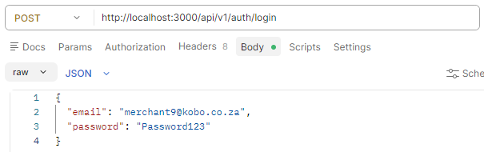
EXPECTED RESULTS:
- Login successful (Status code 200)
- JWT token returned

ACTUAL RESULT: Token received
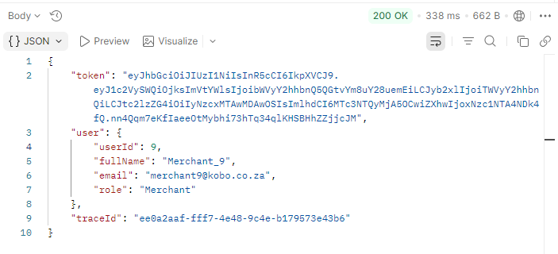

ATTEMPT TO UPDATE PRODUCT USING USER TOKEN:
JSON Request body:
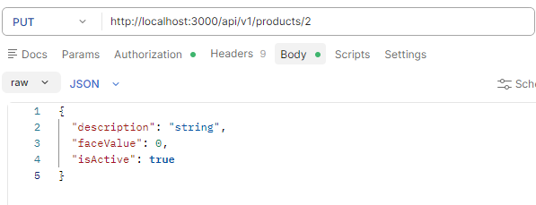

EXPECTED RESULTS:
- Access is forbidden (Error 403 showed)
- The user is denied due to lack of permissions

ACTUAL RESULT: User is denied access
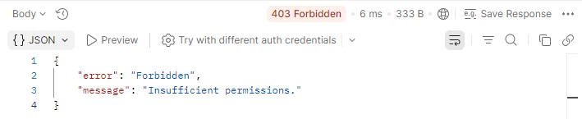

TEST CASE 6: USER 10
Role: Merchant
Email: merchant9@kobo.co.za
LOGIN AS MERCHANT:
Method: POST
Endpoint: /api/v1/auth/login
JSON REQ Body:
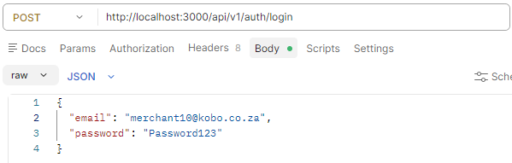
EXPECTED RESULTS:
- Login successful (Status code 200)
- JWT token returned

ACTUAL RESULT: Token received
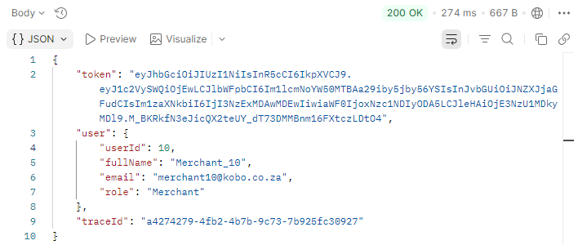

ATTEMPT TO TOPUP A WALLET USING USER TOKEN:
JSON Request body:
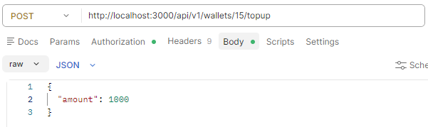
EXPECTED RESULTS:
- Access is forbidden (Error 403 showed)
- The user is denied due to lack of permissions

ACTUAL RESULT: User is denied access
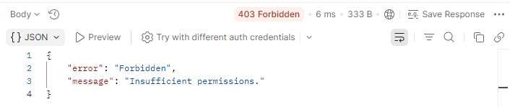

TEST CASE 7: USER 11
Role: Merchant
Email: merchant9@kobo.co.za
LOGIN AS MERCHANT:
Method: POST
Endpoint: /api/v1/auth/login
JSON REQ Body:
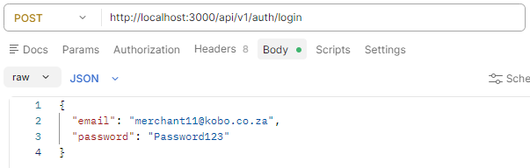
EXPECTED RESULTS:
- Login successful (Status code 200)
- JWT token returned

ACTUAL RESULT: Token received
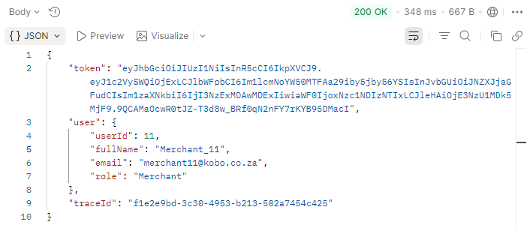

ATTEMPT TO CREATE A COMMISSION RULE USING USER TOKEN:
JSON Request body:
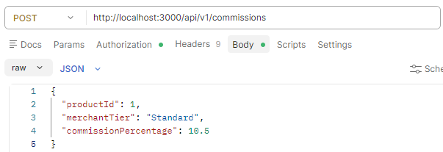
EXPECTED RESULTS:
- Access is forbidden (Error 403 showed)
- The user is denied due to lack of permissions

ACTUAL RESULT: User is denied access


TEST CASE 8: USER 13
Role: Merchant
Email: merchant9@kobo.co.za
LOGIN AS MERCHANT:
Method: POST
Endpoint: /api/v1/auth/login
JSON REQ Body:
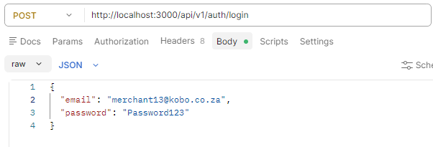
EXPECTED RESULTS:
- Login successful (Status code 200)
- JWT token returned

ACTUAL RESULT: Token received
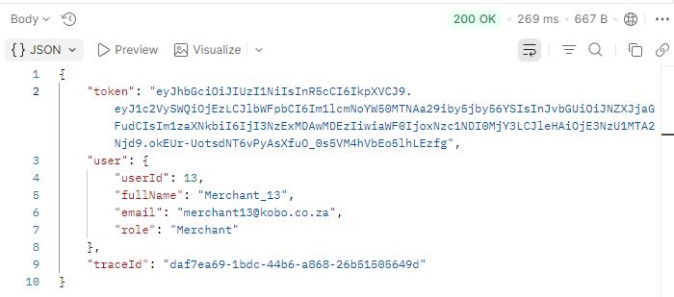

ATTEMPT TO UPDATE AN EXISTING COMMISSION RULE:
JSON Request body:
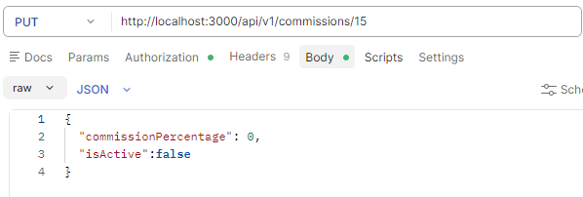
EXPECTED RESULTS:
- Access is forbidden (Error 403 showed)
- The user is denied due to lack of permissions

ACTUAL RESULT: User is denied access


TEST CASE 9: USER 14
Role: Merchant
Email: merchant14@kobo.co.za
LOGIN AS MERCHANT:
Method: POST
Endpoint: /api/v1/auth/login
JSON REQ Body:
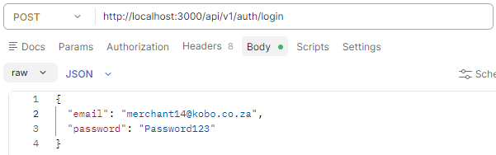
EXPECTED RESULTS:
- Login successful (Status code 200)
- JWT token returned

ACTUAL RESULT: Token received
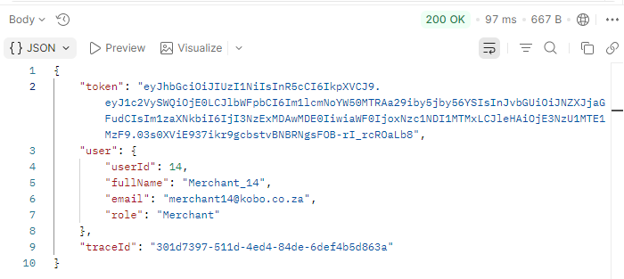

ATTEMPT TO DELETE AN EXISTING COMMISSION RULE USING USER TOKEN:
Endpoint URL:
EXPECTED RESULTS:
- Access is forbidden (Error 403 showed)
- The user is denied due to lack of permissions

ACTUAL RESULT: User is denied access
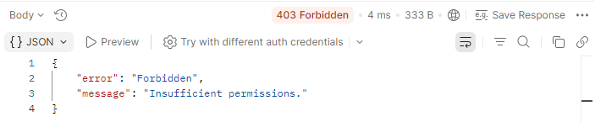

TEST CASE 10: USER 15
Role: Merchant
Email: merchant15@kobo.co.za
LOGIN AS MERCHANT:
Method: POST
Endpoint: /api/v1/auth/login
JSON REQ Body:
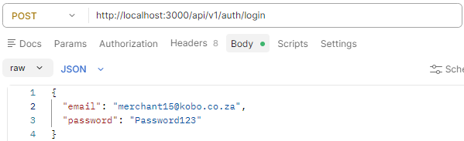

EXPECTED RESULTS:
- Login successful (Status code 200)
- JWT token returned

ACTUAL RESULT: Token received
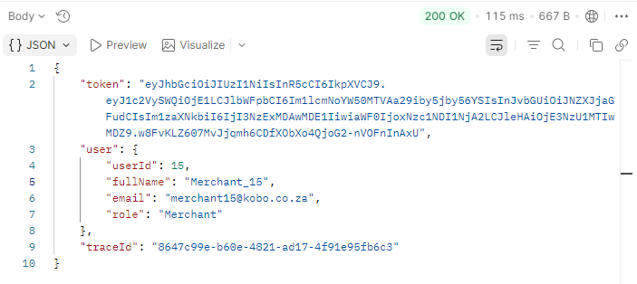

ATTEMPT TO CALCULATE SETTLEMENTS USING USER TOKEN:
JSON Request body:
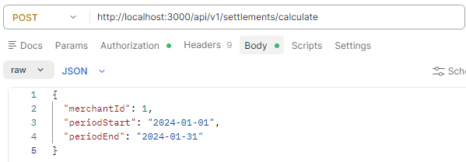

EXPECTED RESULTS:
- Access is forbidden (Error 403 showed)
- The user is denied due to lack of permissions

ACTUAL RESULT: User is denied access
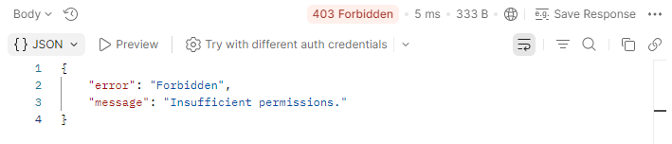

TEST CASE 11: USER 16
Role: Merchant
Email: merchant16@kobo.co.za
LOGIN AS MERCHANT:
Method: POST
Endpoint: /api/v1/auth/login
JSON REQ Body:
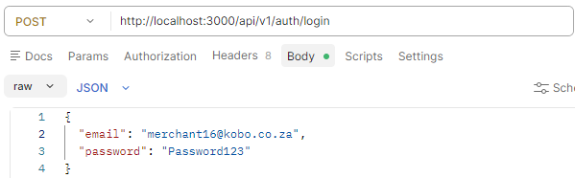

EXPECTED RESULTS:
- Login successful (Status code 200)
- JWT token returned

ACTUAL RESULT: Token received
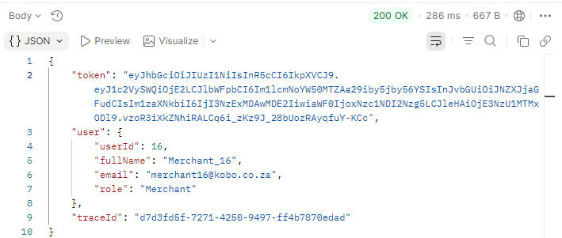

ATTEMPT TO ACCESS GLOBAL TRANSACTION LEDGER USING USER TOKEN:
Endpoint URL:
EXPECTED RESULTS:
- Access is forbidden (Error 403 showed)
- The user is denied due to lack of permissions

ACTUAL RESULT: User gained unauthorized access to the Global transaction ledger
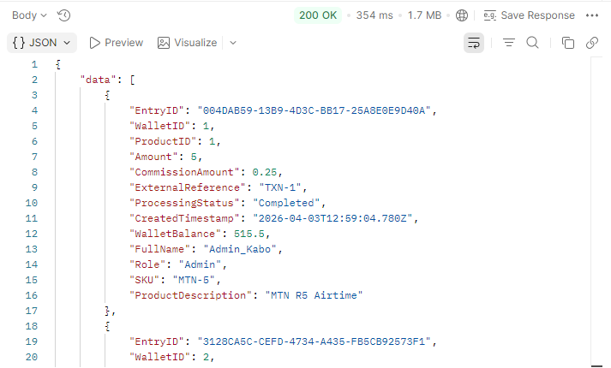

TEST CASE 12: USER 17
Role: Merchant
Email: merchant17@kobo.co.za
LOGIN AS MERCHANT:
Method: POST
Endpoint: /api/v1/auth/login
JSON REQ Body:
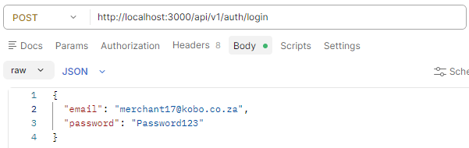
EXPECTED RESULTS:
- Login successful (Status code 200)
- JWT token returned

ACTUAL RESULT: Token received
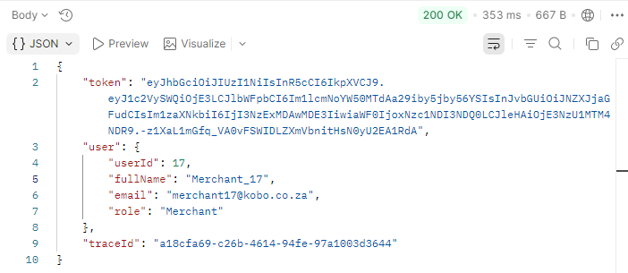

ATTEMPT TO GET USER SENSITIVE DATA USING USER TOKEN:
Endpoint URL:
EXPECTED RESULTS:
- Access is forbidden (Error 403 showed)
- The user is denied due to lack of permissions

ACTUAL RESULT: User is denied access
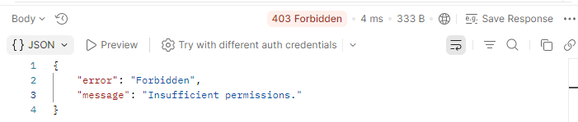

TEST CASE 13: USER 19
Role: Merchant
Email: merchant19@kobo.co.za
LOGIN AS MERCHANT:
Method: POST
Endpoint: /api/v1/auth/login
JSON REQ Body:
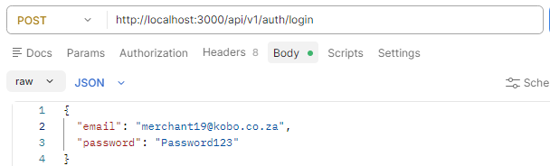

EXPECTED RESULTS:
- Login successful (Status code 200)
- JWT token returned

ACTUAL RESULT: Token received
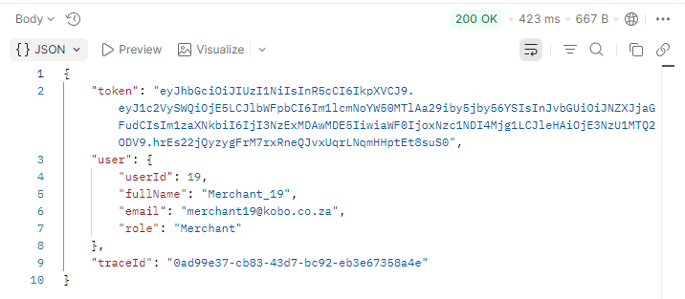
ATTEMPT TO MERCHANTS WITH FINANCIALS
Endpoint URL:
EXPECTED RESULTS:
- Access is forbidden (Error 403 showed)
- The user is denied due to lack of permissions

ACTUAL RESULT: User is denied access


TEST CASE 14: USER 1
Role: Admin
Email: kabo@kobo.co.za
LOGIN AS ADMIN:
Method: POST
Endpoint: /api/v1/auth/login
JSON REQ Body:
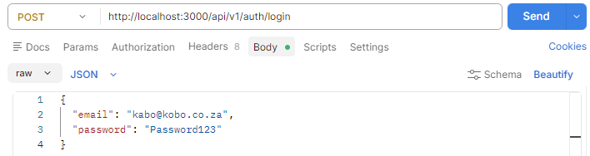
EXPECTED RESULTS:
- Login successful (Status code 200)
- JWT token returned

ACTUAL RESULT: Token received
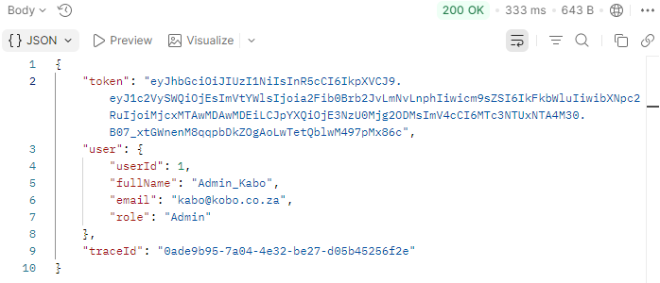

ATTEMPT TO VIEW ALL SETTLEMENTS:
Endpoint URL:
EXPECTED RESULTS:
- Successful display of settlements (status code 200)
- The user has access due to being an admin

ACTUAL RESULT: User can retrieve all settlements
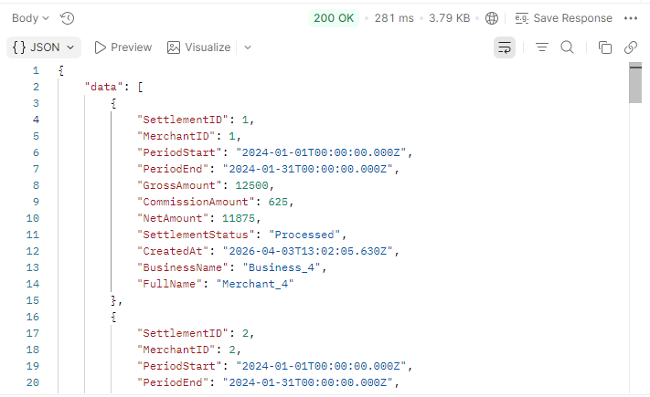

TEST CASE 15: USER 21
Role: Merchant
Email: merchant21@kobo.co.za
LOGIN AS MERCHANT:
Method: POST
Endpoint: /api/v1/auth/login
JSON REQ Body:
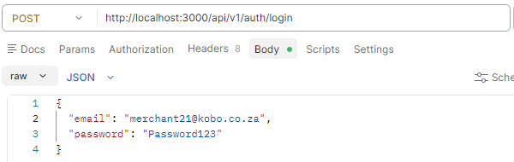
EXPECTED RESULTS:
- Login successful (Status code 200)
- JWT token returned

ACTUAL RESULT: Token received
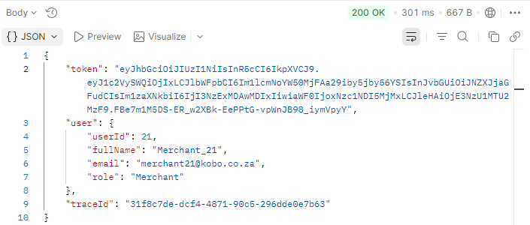

ATTEMPT TO BULK UPDATE COMMISSION RATES FOR A TIER USING USER TOKEN:
JSON Request body:
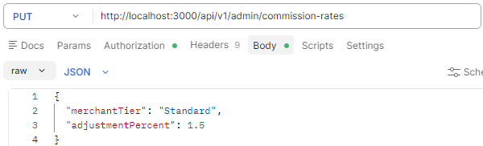

EXPECTED RESULTS:
- Access is forbidden (Error 403 showed)
- The user is denied due to lack of permissions

ACTUAL RESULT: User is denied access
